Free Workshop Series for Young Self- Advocates And Those Who Support
Individuals with Disabilities

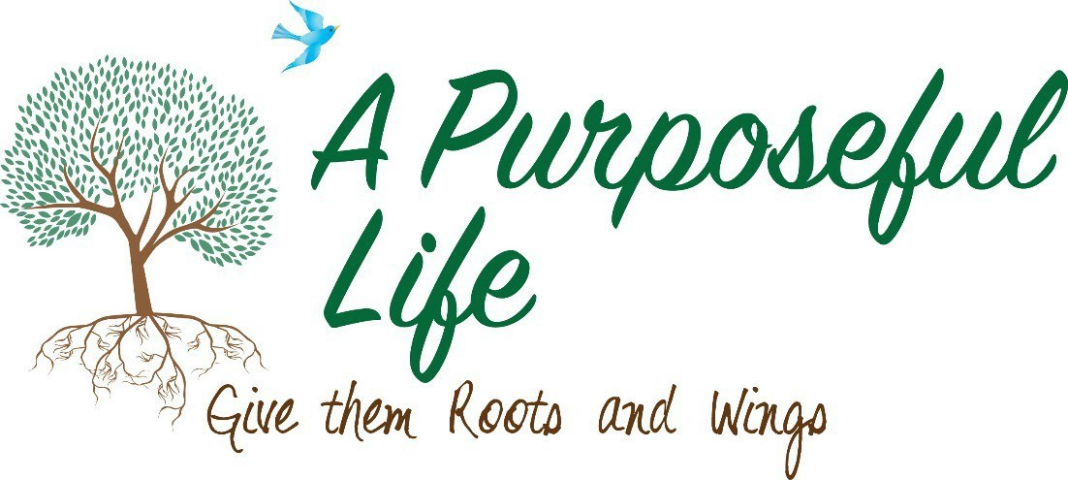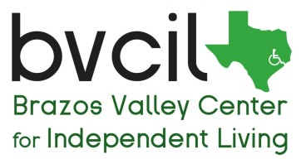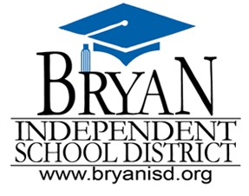September 7, 2017
Everyone Has Differences, Mine Just Has A Name
Talking to your child about their disability

October 5, 2017
Why Punishment May Not Be Working
Learn to change behavior with positive behaviors supports

November 2, 2017
You Can Get Results...But They Might Not Be For The Best
Collaboration with schools

December 7, 2017
Your Unexpected Journey
Discussing the recurring grief of parenting a child with a disability

- FREE DINNER
- FREE CHILDCARE (ages 2 and up)
- FREE YOUTH TRAINING (ages 11 and up)
- FREE SIBLING SUPPORT GROUP (ages 11 and up)

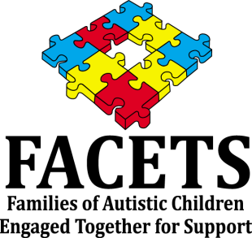Register online at cdd.tamu.edu (under Service and Outreach) For accessibility or transportation requests contact Pat Morse at
BVCIL (979.776.5505.) Requests must be made one week in advance.

Where:
Central Baptist Church Fellowship Room 1991 FM 158 Road
College Station

When:
6:00pm-7:30pm
Check-in 5:45pm

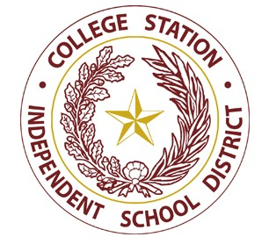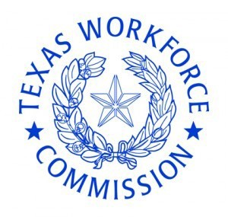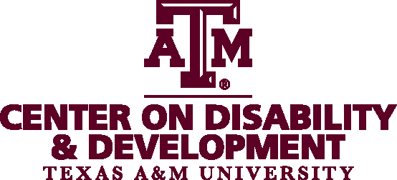Collaborating Organizations

